**Pizza Sales SQL Queries**

A. KPIS

1. **Total Revenue:**

SELECT SUM(total_price) AS Total_Revenue FROM pizza_sales

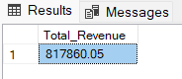

1. **Average Order Value:**

SELECT (SUM(total_price) / COUNT(DISTINCT order_id)) AS Average_Sales FROM pizza_sales

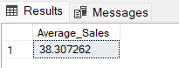

1. **Total Pizzas Sold:**

SELECT SUM(quantity) AS Pizzas_Sold FROM pizza_sales

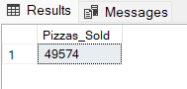

1. **Total Orders:**

SELECT COUNT(DISTINCT order_id) AS Total_Orders FROM pizza_sales

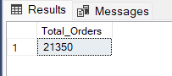

1. **Average Pizzas Per Order:**

SELECT CAST((CAST(SUM(quantity) AS DECIMAL(10,2))/COUNT(DISTINCT order_id)) AS DECIMAL(10,2)) AS Total_Pizzas_Per_Order FROM pizza_sales

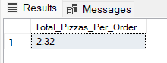

B. Charts Requirements

1. **Daily Trend for Total Orders:**

SELECT DATENAME(DW, order_date) AS order_day, COUNT(DISTINCT order_id) AS Total_orders

FROM pizza_sales

GROUP BY DATENAME(DW,order_date)

ORDER BY Total_orders DESC

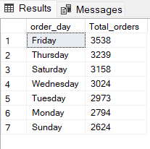

1. **Monthly Trend for Total Orders:**

SELECT DATENAME(MM, order_date) AS order_month, COUNT(DISTINCT order_id) AS Total_orders

FROM pizza_sales

GROUP BY DATENAME(MM,order_date)

ORDER BY Total_orders DESC

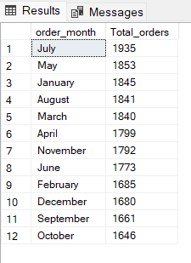

1. **Percentage of Sales by Pizza Category:**

SELECT pizza_category, SUM(total_price) AS Total_Sales, CAST(SUM(total_price) * 100 / (SELECT SUM(total_price) FROM pizza_sales) AS DECIMAL(10,2))AS PCT_Sales

FROM pizza_sales

GROUP BY pizza_category

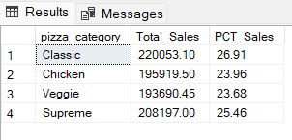

1. **Percentage of Sales by Pizza Size:**

SELECT pizza_size, SUM(total_price) AS Total_Sales, CAST(SUM(total_price) * 100 / (SELECT SUM(total_price) FROM pizza_sales) AS DECIMAL(10,2))AS PCT_Sales

FROM pizza_sales

GROUP BY pizza_size

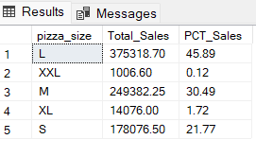

1. **Percentage of Pizzas Sold by Pizza Category:**

SELECT pizza_category, SUM(quantity) AS Pizzas_Sold,CAST(CAST(SUM(quantity) * 100 AS DECIMAL(10,2))/CAST((SELECT SUM(quantity) FROM pizza_sales)AS DECIMAL(10,2)) AS DECIMAL (10,2)) AS PCT_Pizzas_Sold

FROM pizza_sales

GROUP BY pizza_category

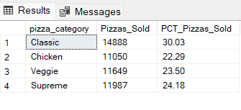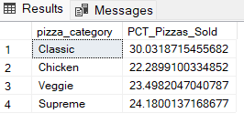

1. **Top 5 Selling Pizzas** 
   1. **by Total Pizzas Sold:**

SELECT TOP 5 pizza_name, SUM(quantity) AS Total_Sold, SUM(total_price) AS Total_Revenue

FROM pizza_sales

GROUP BY pizza_name

ORDER BY Total_Sold DESC

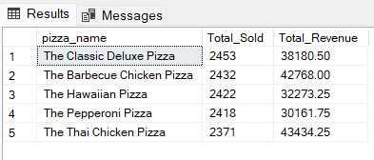

* 1. **By Total Revenue:**

SELECT TOP 5 pizza_name, SUM(quantity) AS Total_Sold, SUM(total_price) AS Total_Revenue

FROM pizza_sales

GROUP BY pizza_name

ORDER BY Total_Revenue DESC

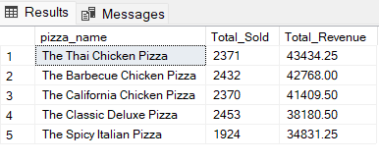

1. **Worst 5 Selling Pizzas by Total Pizzas Sold:**
   1. **by Total Pizzas Sold:**

SELECT TOP 5 pizza_name, SUM(quantity) AS Total_Sold, SUM(total_price) AS Total_Revenue

FROM pizza_sales

GROUP BY pizza_name

ORDER BY Total_Sold ASC

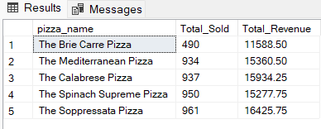

* 1. **By Total Revenue:**

SELECT TOP 5 pizza_name, SUM(quantity) AS Total_Sold, SUM(total_price) AS Total_Revenue

FROM pizza_sales

GROUP BY pizza_name

ORDER BY Total_Revenue ASC

